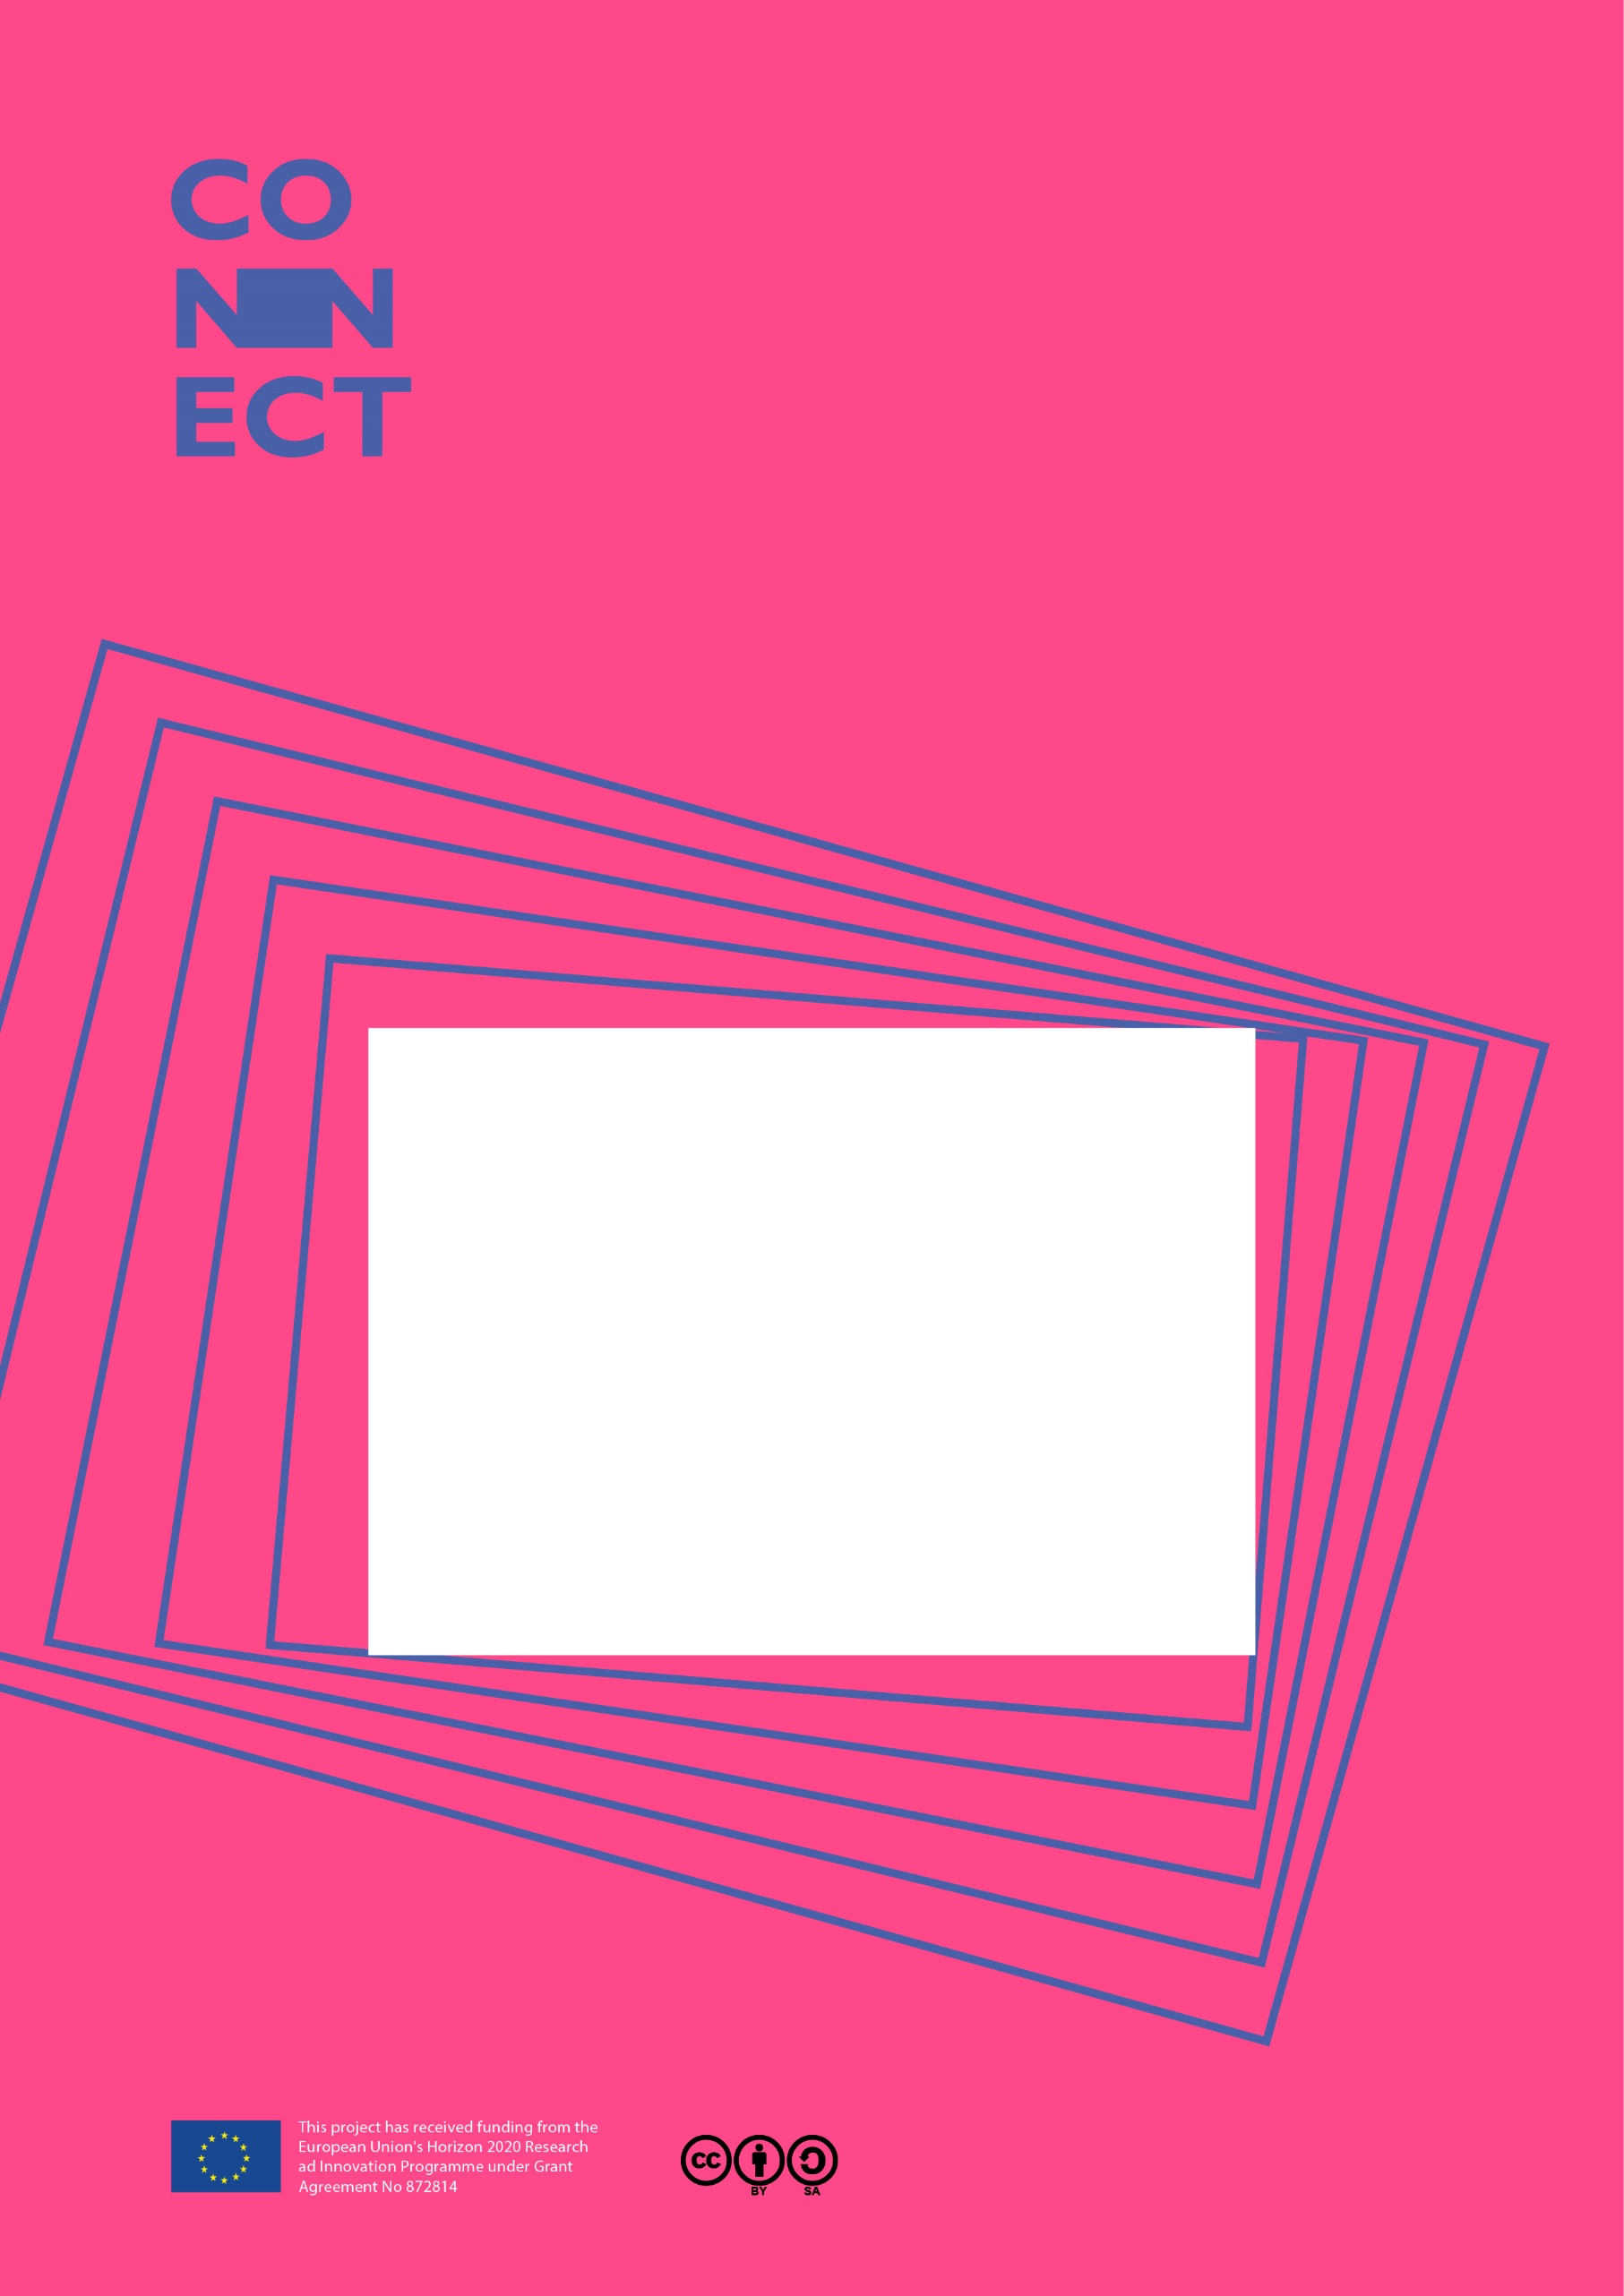

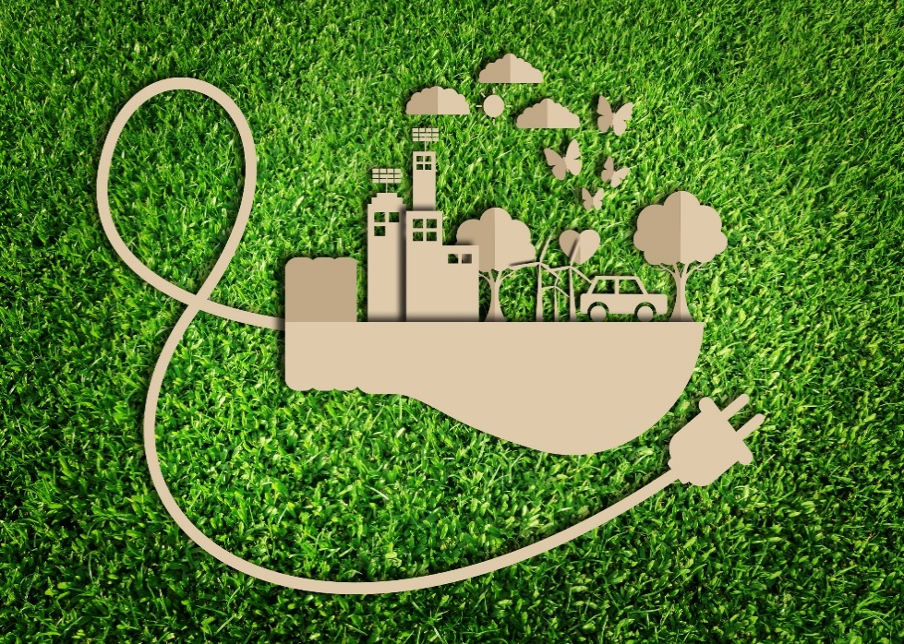

This project received funding from the European Union’s Horizon 2020 Research and Innovation programme under GA nº. 872814

*For Scientists*

Energy savers

Contents

1 It’s part of CONNECT 3

1.1 Overview of Energy savers 3

2 The activities 4

2.1 CARE: The Challenge 4

2.2 DO: Advise 4

Presenting your work 6

*In compliance with*

|  |  |  |  |  |  |
| --- | --- | --- | --- | --- | --- |
|  | | | | | |
|  |  |  |  |  |  |
|  |  |  |  |  |  |
|  |  |  |  |  |  |

# It’s part of CONNECT

In the race for exam results it can be easy to forget the other goals of a good science education - scientific literacy and preparation for a STEM career. You can add weight to these goals with CONNECT. It’s an EC-funded project which offers a new kind of resource - a **Science Action**. It’s aset of activities to integrate a real-life challenge into an existing topic. It ticks lots of boxes:

* Applies a science concept
* Teaches an enquiry skill
* Provides an authentic end of topic assessment
* Shows students how science affects their world
* Gets students interacting with a scientist or engineer (supplied by the project)
* Encourages students to talk about science with their family

## Overview of Energy savers

There are huge companies like Tesla trying to protect the planet by reducing our emissions from fossil fuels. There are also smaller companies trying to invent and sell devices to reduce energy consumption with energy-saving inventions for homes. But to produce them they need money - investors.

In the Energy savers science-action students are asked help an inventor friend produce a low-budget energy-saving device and create a crowd-funding page. They use their knowledge of energy transfers and wasted energy, and the enquiry skills of Represent with models and Use fractions and percentages.

There are two activities:

|  |  |  |  |
| --- | --- | --- | --- |
| Activity | **Learning objective** | **What students do** | **Who can be involved** |
| CARE: The challenge | Care about the issue  Understand the scientific context | Rank ideas for energy-saving devices on how much energy they save, if they will work and how useful they are. | Teacher,  STEM professional  Family |
| DO: Design | Coordinate scientific knowledge and skill in a performance assessment. | Use enquiry skills to finish the design of the device and create a crowd-funding page. | Teacher  STEM professional |

# The activities

## CARE: The Challenge

Students are introduced to energy-saving devices using an engaging context – to help an inventor friend design and fund a new invention. At home they review the ideas and rank them.

You could talk to students about why we need to use more energy efficient devices, or about the latest energy-efficient inventions. You could do this face to face, record a short video or talk to the students remotely.

## DO: Advise

In this activity, students practise the scientific enquiry skills: Represent with models and use fractions and percentages. They help the inventor by choosing the most efficient solar panel for the SolarCap and completing the funding page.

It is recommended that you view the resource for this activity: **05 STUDENT SHEETS Energy savers**

There are several ways you can help students:

* Explaining how STEM professionals use the skill in their work
* Guiding students as they practise using the skills
* Review the quality of the work
* Give praise and feedback to students

The teacher’s lesson plan for this activity is shown below:

|  |  |
| --- | --- |
| Stage/purpose | **Running notes** |
| **DESIGN A PROJECT PAGE**  Students calculate efficiency and complete an energy transfer diagram | Go through each of the invention ideas from the CARE Home activity. Ask students to raise their hands if they ranked it first to reveal the class’s top invention. Invite students to explain how they scored certain inventions.  Give out the student sheets.  Read through the tasks with the class so they understand what they need to do.  **The STEM professional can recap what a Sankey diagram shows and how to calculate efficiency in a different context to the solar panels. They can also explain why efficiency is an important feature of electrical devices.**  Students then complete the tasks on SS1.  For part D they need to persuade members of the public to fund the cap by explaining why they would want one. This can optionally be done at home, which will give them time to do extra research on why we should be using renewable forms of energy.  Answers  B: How it works.  Graphical user interface, application, Word  Description automatically generated  C: How it saves energy  Type A: (20/100) x 100 = 20%  Type B: (32/200) x 100 = 16%  Type C: (33/150) x 100 = 22%  Type C is the best choice. More of the input energy coming from the light pathway will be transferred to the electrical pathway so it will charge up the phone the fastest. |

# Presenting your work

You may be asked to talk to the class about your work. Here are some tips for keeping students engaged:

* Start with an interesting visual or question
* Communicate the information as a story
* Make it interactive and ask questions

And here’s some guidance to help you keep things simple:

* Use actual examples instead of abstract ideas
* Don’t use too much data
* Check the terminology you use with the teacher

