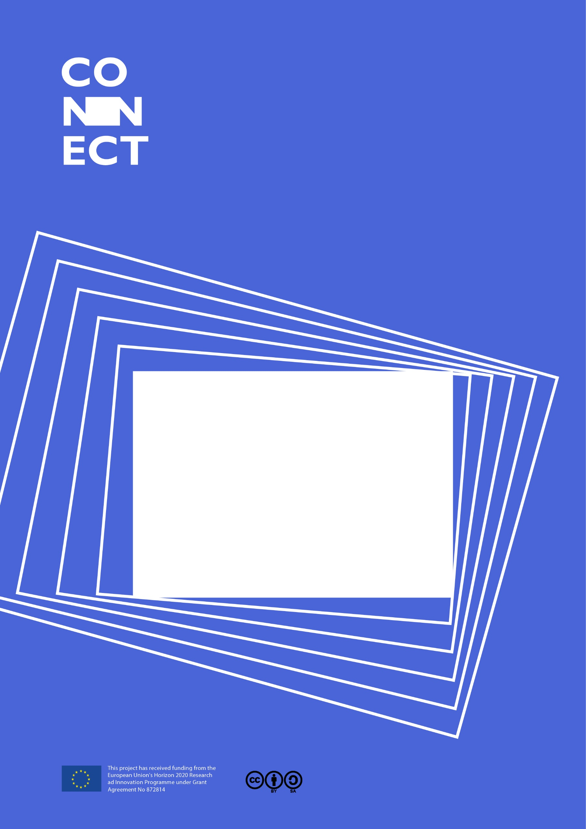

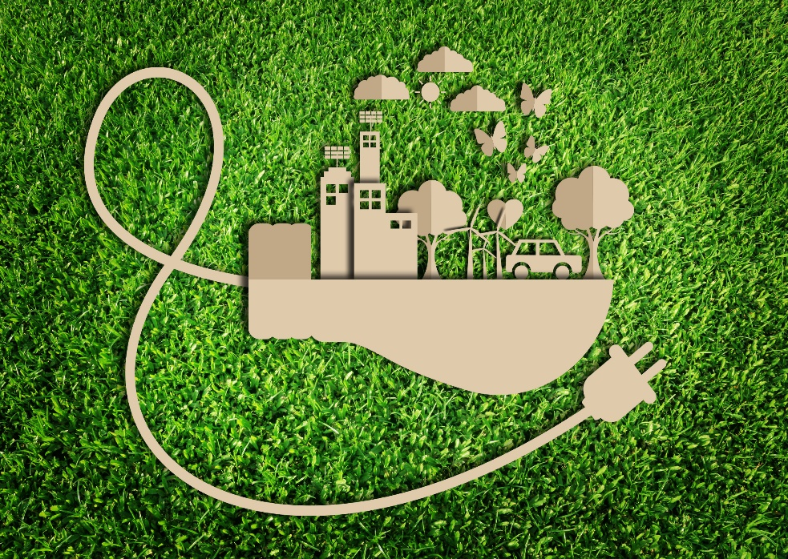

This project received funding from the European Union’s Horizon 2020 Research and Innovation programme under GA nº. 872814

*For Teachers*

Energy savers

Contents

1 It’s part of CONNECT 3

1.1 Overview of Energy savers 3

1.2 Involve a STEM professional 4

1.3 Involve families 4

2 CARE: The Challenge 5

2.1 Lesson plan 5

3 DO: Design 6

3.1 Lesson plan 6

*In compliance with*

|  |  |  |  |  |  |
| --- | --- | --- | --- | --- | --- |
|  | | | | | |
|  |  |  |  |  |  |
|  |  |  |  |  |  |
|  |  |  |  |  |  |

# It’s part of CONNECT

In the race towards exam it can be easy to forget the other goals of science education - scientific literacy and STEM careers. You can work towards these missing goals using - CONNECT an EC-funded project which offers a new kind of resource. Called a **Science Action**, it’s aset of activities to integrate a real-life challenge into an existing topic. It ticks lots of boxes:

* Applies a science concept
* Teaches an enquiry skill
* Provides an authentic end of unit assessment
* Shows students how science affects their world
* Gets students interacting with a scientist or engineer (supplied by the project)
* Encourages students to talk about science with their family

## Overview of Energy savers

There are huge companies like Tesla trying to protect the planet by reducing our emissions from fossil fuels. There are also smaller companies trying to invent and sell devices to reduce energy consumption with energy-saving inventions for homes. But to produce them they need money - investors.

In the Energy savers science-action students are asked help an inventor friend produce a low-budget energy-saving device and create a crowd-funding page. They use their knowledge of energy transfers and wasted energy, and the enquiry skills of Represent with models and Use fractions and percentages.

There are two activities:

|  |  |  |  |
| --- | --- | --- | --- |
| Activity | **Learning objective** | **What students do** | **Who can be involved** |
| CARE: The challenge | Care about the issue  Understand the scientific context | Rank ideas for energy-saving devices on how much energy they save, if they will work and how useful they are. | Teacher,  STEM professional  Family |
| DO: Design | Coordinate scientific knowledge and skill in a performance assessment. | Use enquiry skills to finish the design of the device and create a crowd-funding page. | Teacher  STEM professional |

Energy savers integrates with the Year 7 unit Energy. It is a short science action, designed to take around one lesson. We recommend it is used at the end of the unit.

Yellow boxes = existing lessons. Green boxes = Energy savers activities.

## Involve a STEM professional

Energy savers provides an easy-to-use and effective approach for involving a scientist or engineer. This will give students insight into STEM careers and make the issue more real.

If you are working with a STEM professional, give them the ‘Information for STEM professional’. It has full details of the activities they can support:

**DO: Design:** to help students practice the enquiry skill, by explaining it or guiding students as they practise it.

The detailed running notes below describe these roles.

Some scientists can also support the first activity:

**CARE: The challenge** A scientist or engineer can talk about why we need to use more energy efficient devices, or about the latest energy-efficient inventions.

## Involve families

Energy savers allows you to engage parents or other family members in talking about science. This could especially benefit those students whose families have little experience of science.

**CARE: The challenge** In the ‘home’ task, families help the inventor to choose a device to manufacture. They read through ideas for energy-saving inventions. They discuss how much energy they will save, if they think they will work and how useful they think they are in order to score the inventions and rank them.

# CARE: The Challenge

Students are introduced to energy-saving devices using an engaging context – to help an inventor friend design and fund a new invention. At home they review the ideas and rank them.

If you are using a STEM professional, the running notes show how they can help, **in bold**.

Advanced preparation:

* Print out a copy of **04 HOME Energy savers CARE** for each studentor make the sheets available online.

## Lesson plan

|  |  |
| --- | --- |
| Stage/purpose | **Running notes** |
| **AT SCHOOL** Introduce energy-saving devices | Use the presentation **03 LESSON Energy savers CARE.** The students learn about an exciting energy-saving idea – Elon Musk’s Hyperloop (4-5). Recap what they know about wasted energy (6). Introduce them to the challenge to help their friend (7-8).  **If you are using a STEM professional, they could talk about why we need to use more energy efficient devices (in terms of reducing carbon emissions), or about the latest energy-efficient inventions.** |
| **AT HOME** Families score and rank the ideas | Families follow the instructions on the document **04 HOME** **Energy savers CARE**. They look through the ten inventions and score them according to three different criteria. They add up the scores to rank the inventions. |

# DO: Design

In this activity, students practice the scientific enquiry skills: Represent with models and use fractions and percentages. They help the inventor by choosing the most efficient solar panel for the SolarCap and completing the funding page.

If you are using a STEM professional, the running notes show how they can help, **in bold**.

Print the student sheets from the document: **05 STUDENT SHEETS Energy savers.**

**SS1**: Task sheet: Helping the inventor (one per pair)

**SS2**: Data sheet (one per pair)

**SS3:** Fundraising page (one per student)

## Lesson plan

|  |  |
| --- | --- |
| Stage/purpose | **Running notes** |
| **DESIGN A PROJECT PAGE**  Students calculate efficiency and complete an energy transfer diagram | Go through each of the invention ideas from the CARE Home activity. Ask students to raise their hands if they ranked it first to reveal the class’s top invention. Invite students to explain how they scored certain inventions.  Give out the student sheets.  Read through the tasks with the class so they understand what they need to do.  **The STEM professional can recap what a Sankey diagram shows and how to calculate efficiency in a different context to the solar panels. They can also explain why efficiency is an important feature of electrical devices.**  Students then complete the tasks on SS1.  For part D they need to persuade members of the public to fund the cap by explaining why they would want one. This can optionally be done at home, which will give them time to do extra research on why we should be using renewable forms of energy.  Answers  B: How it works.    C: How it saves energy  Type A: (20/100) x 100 = 20%  Type B: (32/200) x 100 = 16%  Type C: (33/150) x 100 = 22%  Type C is the best choice. More of the input energy coming from the light pathway will be transferred to the electrical pathway so it will charge up the phone the fastest. |

